# CS 255 System Design Document Template

## UML Diagrams

### UML Use Case Diagram

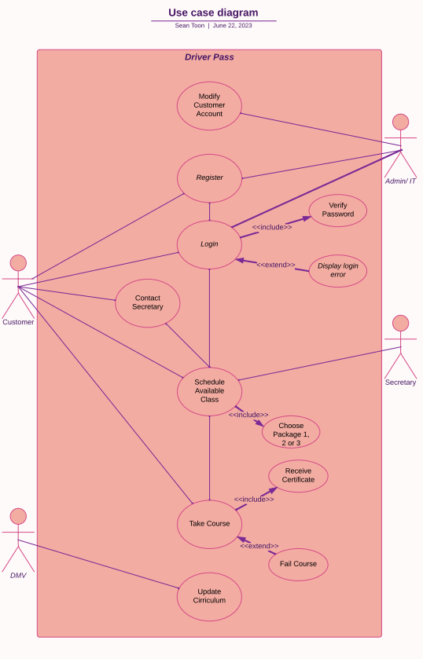

### UML Activity Diagrams

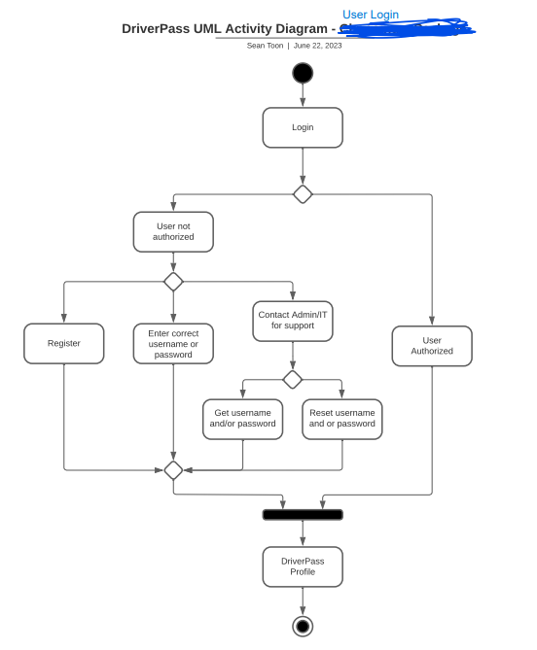

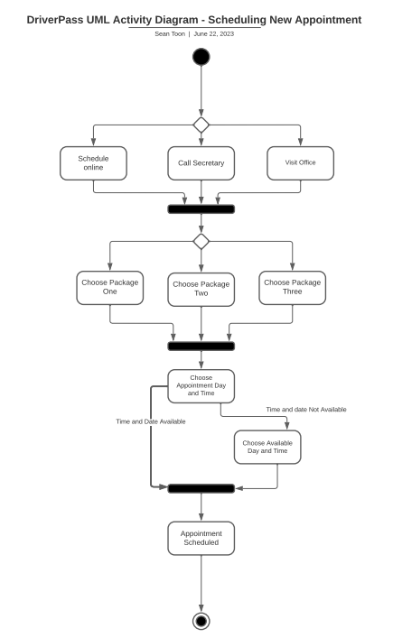

### UML Sequence Diagram

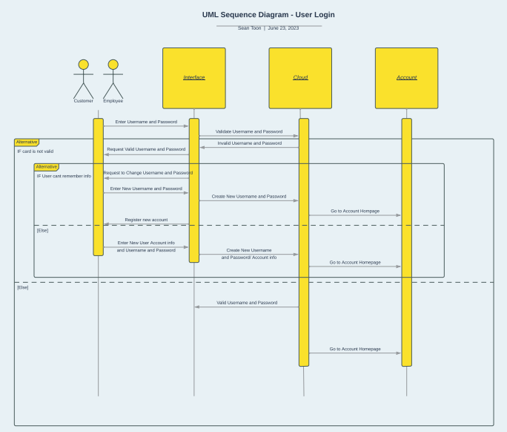

### UML Class Diagram

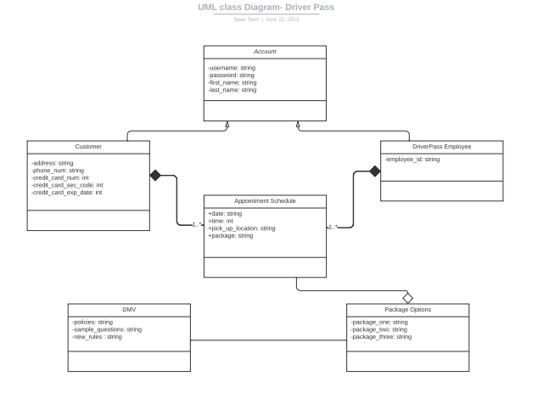

## Technical Requirements

The hardware that will be needed to access DriverPass is any basic computer system such as desktops, laptops, smartphones, tablets. The software will use the cloud for data security. Registering and scheduling appointments with DriverPass can also be accomplished through phone calls and in person meetings. At the DriverPass headquarters there will be main computer systems that are used to manage and operate the DriverPass website and application.